**TIẾT 1: REVISION**

**1, Present simple tense :**

* To be: am , is , are

I am

He, She, It + is

You, We, They + are

Ex: I am a student.

I am not a student.

Are you a student?

* Normal verbs:

(+) S+ V / V –s ,- es

(-) S+ don’t / doesn’t + V

(?) Do/ Does+ S+ V?

Ex: He goes to school by bike.

He doesn’t go to school by bike.

Does she go to school by bike?

**2, The present progressive tense:**

(+) S + am , is ,are + V-ing

(-) S + am, is, are + not +V-ing

(?) Am, Is, Are + S + V-ing?

Ex: Nam is playing video games now.

Nam is not playing video games now .

Is Nam playing video games now ?

* Give the correct tense of the verbs in the brackets :

1, This ( be) . . . my new friend .

2, He ( have ) . . . breakfast at six o’clock.

3, The students ( play). . . soccer at the moment .

4, They (be) . . . her parents .

5, What you ( do) . . . now ?

6, Which class ( be) . . . she in ?

7, Who he ( live). . .. with ?

8, The boys (be) . . . in the room now .

9, My sister (have) . . . English at 7.50 .

10, Her mother (go) to the market every morning .

sǝoƃ ˙0Ɩ ؛sɐɥ ˙6 ؛ǝɹ∀ ˙8 ؛ǝʌıʃ -sǝop ˙ㄥ ؛sı ˙9 ؛ƃuıop -ǝɹɐ ˙ϛ ؛ǝɹɐ ˙ㄣ ؛ƃuıʎɐʃd ǝɹɐ ˙Ɛ ؛sɐɥ ˙ᄅ ؛sı ˙Ɩ :sɹǝʍsu∀

**TIẾT 2: Unit 1: BACK TO SCHOOL**

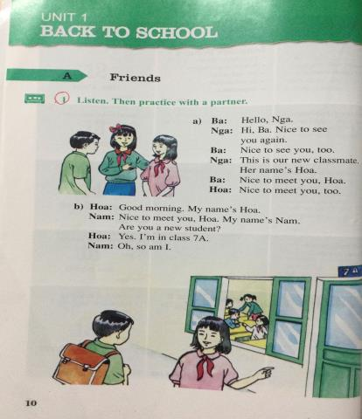**A. FRIENDS**

**VOCABULARY (TỪ VỰNG)**

1. classmate (n.) : bạn cùng lớp

2. Nice to meet you: rất vui khi gặp bạn

3. so am I: mình cũng vậy

4. class (n.): lớp học

🡪 classes (n.) : nhiều lớp học

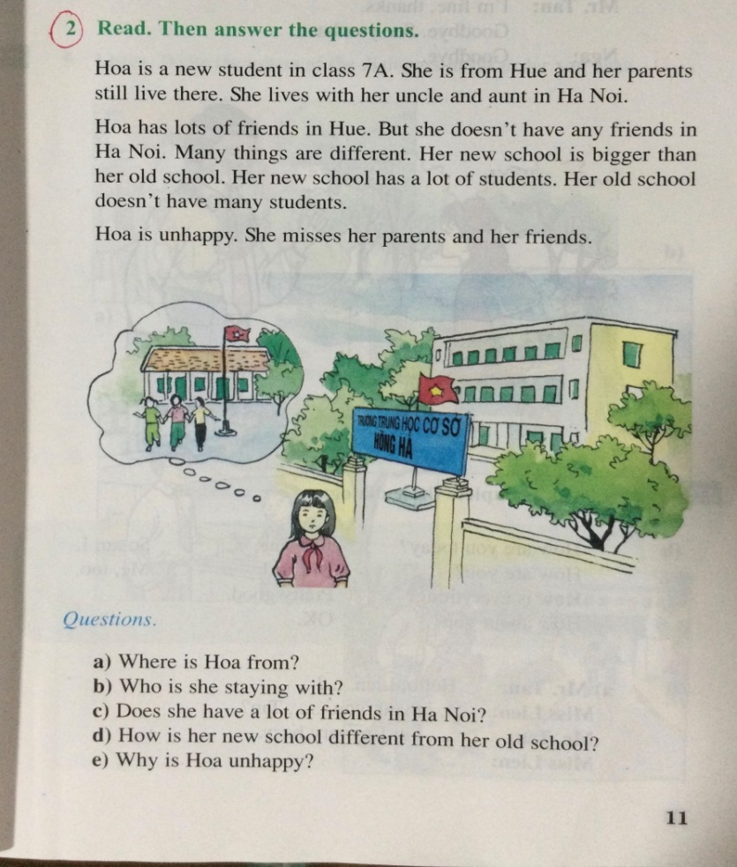

**VOCABULARY**

1. parents (n.) : ba mẹ

2. still (adv.) : vẫn

3. live (v.) : sống

4. unlce (n.): chú, cậu

5. aunt (n.): cô, dì

6. any : bất kì

7. different (from) (a.) : khác (với)

🡪 differ (v.): khác

8. bigger than (a.): lớn hơn

9. a lot of = lost of + N(số nhiều): nhiều

10. many+ N(số nhiều): nhiều

11. unhappy (a.) # happy (a.) : không vui # vui

12. miss (v.) : nhớ

13. friend (n.) : bạn

🡪 friendly (a.) : thân thiện

**EXERCISES (BÀI TẬP)**

1. **Choose the word or phrase that best fits each of the blanks:**

1. Nam is a friendly person. He has______________ friends.

A. some             B. a lot of             C. few   D. much

2. When I'm away from home, I ______________my family very much.

A. love                 B. miss                  C. like          D. hate

3. She lives in the Ha Noi but her parents ______________ in Hue.

A. still live                  B. live still               C. live               D. A & C

4. She doesn’t have ____________ friends.

A. much                            B. many                 C. a lot of               D. b & c

5. She has _____________ of friends in the.

A. some                               B. any                 C. lots                    D. lot

1. **Give the correct forms of the words in parentheses:**
2. Today Lien is _______________________ because she misses her parents. (**happy**)
3. There are thirty-six _____________________ in our school. (**class**)
4. Her new school______________________ than her old school. ( **big**)
5. Many things in Hanoi are ______________________ from in Hue. ( **differ**)
6. **Read the passage then choose the best answer for each blank:**

Hoa is a new student in (1) ___________7A. She is from Hue and her parents still live there. She (2)__________ with her uncle and aunt in Hanoi.

Hoa has (3) __________ of friends in Hue. But she doesn't have (4)__________ friends in Ha Noi. Many things are different. Her new school is bigger (5)____________ her old school. Her new school has a lot of students. Her old school doesn’t have many students.

Hoa is unhappy. She(6) ____________ her parents and her friends.

1. A. class B. classmates C. classmate D. school
2. A. live B. lives C. to live D. living
3. A. lot B. a C. a lots D. lots
4. A. any B. many C. some D. a
5. A. then B. that C. than D. this
6. A. misses B. miss C. to miss D. missing
7. **Arrange these words into their correct orders:**

1. doesn’t have/ She/ any friends/ in Ha Noi.

……………………………………………………………………………………………

2. and aunt in Ha Noi./lives / Hoa/ with her uncle /

……………………………………………………………………………………………

**THE END**